SmartPlant 3D Eqp Reference Data v7
User Training

Table of Contents

LAB-1: Catalog Hierarchy 1
Lab 2: Equipment Catalog Hierarchy 5
Lab 3: Working with the Custom Interface Sheet 9

LAB-1: Catalog Hierarchy

Objective
After completing this lab, you will be able to:

- Add/Modify Module Type Hierarchy
- Use Bulkload utility to modify the catalog database

Module Hierarchy

In this lab, you will add two new module classes called TransformerType1 and PipeRackType1 into the Module Type catalog hierarchy. To create the classification folders as shown below, you must edit the ModuleType Excel workbook, which contains three sheets that control the hierarchy: ClassNodeType, R-Hierarchy, and R-ClassNodeDescribes. When you add a module class to the catalog hierarchy, you must update these sheets, where necessary, in order to see the data in the Catalog task or Catalog browser dialog box.

CatalogRoot is the RootNode of the ReferenceData Catalog Browser. It cannot have a parent node. It is a named-object. Similarly RefDataModulesRoot is the root for the module hierarchy which appears as a child of the CatalogRoot. Electrical, Transfomers, Structure and PipeRacks are the nodes to facilitate the easy browsing. TransformerType1 and PipeRackType1 are the Module Classes.

- Open the ModuleTypes.xls Excel workbook. Copy this file to a working folder from: C:\Program Files\SmartPlant\3D\CatalogData\BulkLoad\Datafiles. Don’t modify the delivered one.

- Go to the ClassNodeType sheet and add the following entries. Remember to add the letter A to all new records.

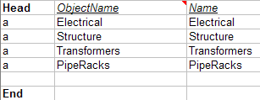

Note: This sheet describes the nodes used to navigate the CatalogBrowser hierarchy.

ObjectName values should be unique across the entire database to identify a node uniquely.
Name is the displayed name which appears in the CatalogBrowser hierarchy.

- Go to the R-Hierarchy sheet and add the following entries. Remember to add the letter A to all new records.
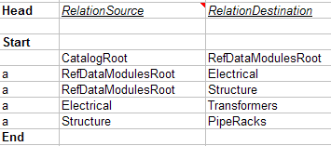

Note: RelationSource and RelationDestination entries are ObjectNames of the objects participating in the relationship. A relationship can’t be made unless the objects mentioned in Relationsource / RelationDestination columns are already created.

- Go to the R-ClassNodeDescribes sheet and add the following entry. Remember to add the letter A to all new records.

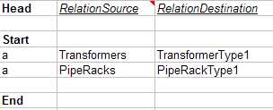

Note: 'R-ClassNodeDescribes' is the relationship between an object from ClassNodeType worksheet as RelationSource and another object which is a PartClass as RelationDestination. RelationSource entries are ObjectNames of the objects participating in the relationship. RelationDestination entries are names of the PartClasses sheets participating in the relationship.

- Copy the Vent Arrangement Class worksheet by doing the following:
Select the Vent Arrangement Sheet tab. Right Click to Open the Move or Copy dialog box. Enable the “create a copy” option. Click GUIDs in the before-sheet box. Select the OK button to copy the Vent Arrangement sheet before the GUIDs sheet.
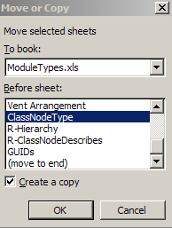

- Rename the new sheet to TransformerType1.

Note: Make sure you do not add any blank space or special characters for the name.

- Repeat the above steps to create the PipeRackType1 class.

- Add ‘A’ on both classes as follows:

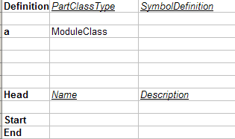

- Save the changes to workbook ModuleTypes.xls and use the Bulkload utility to load the new classes. Remember the letter A should have been added to all new records.
- Using the Bulkload utility
  - Select Start>AllPrograms>Intergraph SmartPlant 3D>Database Tools>Bulkload Reference Data
  - Select the first Add… button next to the Excel files box
  - Navigate to and select the ModuleTypes.xls file that was just saved
  - In the Bulkload mode box select the button next to “Add, modify, or delete records”
  - Leave the “Update Object Type…” box checked
  - In the Database Server name pulldown, select the training plant’s database server
  - In the Database Name pulldown, select the Catalog database for the training plant: SP3DTrain_CDB
  - In the Catalog Schema Database pulldown select: SP3DTrain_CDB_SCHEMA
  - In the log file, select … then Open to place the log in the same folder as the Excel file loaded
  - The Symbol and custom program path should already be set
  - The form should look similar to this:
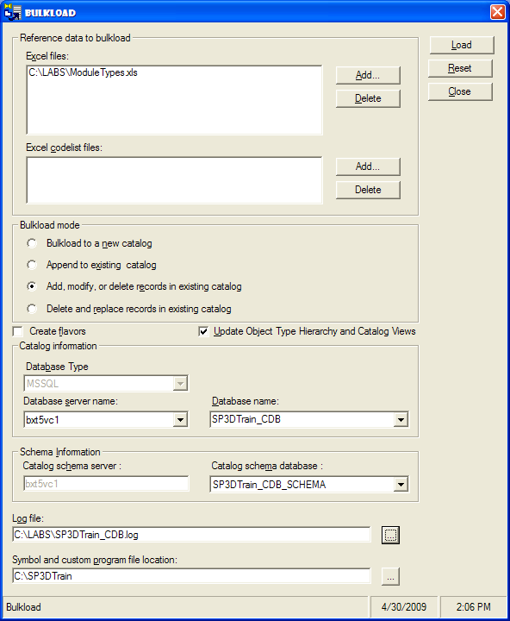
  - Select Load to process the ModuleTypes workbook.
- If bukload was successful proceed to the next step. If errors are reported return to the workbook, find incorrect entries (as compared to screenshot samples above), repair and re-bulkload.
- Open a session into the training plant (review pre-requisite Common Apps class material if help is needed with this)
- To verify that the new modules were created, in 3D graphics select Edit>Paste From Catalog and open the Modules folder to navigate to the Electrical and the Structure nodes’ contents. Verify that the TransformerType1 and PipeRackType1 folders appear. Users will be able to copy items or assemblies into these folders for future use by anybody in this project

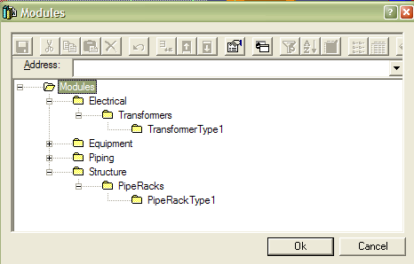

Lab 2: Equipment Catalog Hierarchy
Objective
After completing this lab, you will be able to:

- Add/Modify Equipment Catalog Hierarchy

Equipment Hierarchy
All the nodes (Classification folders) are ClassNodeType objects except for the leaf nodes which are Smart Classes. A relation between two nodes can be created in the 'R-Hierarchy' worksheet. A relation between a ClassNodeType object and a Smart Class can also be created in the 'R-Hierarchy' worksheet.

In this lab, you will add a new smart class called Boiler Type1 into the equipment catalog hierarchy. To create the classification folders as shown below, you must edit the Equipment workbook, which contains two sheets that control the hierarchy: ClassNodeType and R-Hierarchy. When you add a smart class to the catalog hierarchy, you must update these sheets, where necessary, in order to see the data in the Catalog task or Catalog browser dialog box.

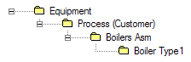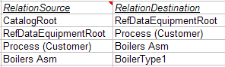

CatalogRoot is the RootNode of the ReferenceData Catalog Browser. It cannot have a parent node. It is a named-object. Similarly Equipment is the root for the equipment hierarchy which appears as a child of the CatalogRoot. Process (Customer) and Boilers Asm are the nodes to facilitate the easy browsing. Boiler Type1 is the Smart Class.

- Open the Equipment.xls Excel workbook. Copy this file to a working folder from: C:\Program Files\SmartPlant\3D\CatalogData\BulkLoad\Datafiles. Don’t modify the delivered one.

- Go to the ClassNodeType sheet and add the following entries. Remember to add the letter A to all new records.

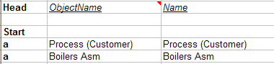

Note: This sheet describes the nodes used to navigate the CatalogBrowser hierarchy.

ObjectName should be unique across the entire database to identify a node uniquely.

Name is the display name which appears in the CatalogBrowser hierarchy.

- Go to the R-Hierarchy sheet and add the following entries. Remember to add the letter A to all new records.

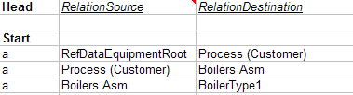

Note: RelationSource and RelationDestination entries are ObjectNames of the objects participating in the relationship. A relationship can’t be made unless the objects mentioned in Relationsource / RelationDestination columns are already created.

- Copy the StorageTankAsm sheet by doing the following:
Select the StorageTankAsm Sheet. Right Click to Open the Move or Copy dialog box. Enable the create a copy option. Select the GUIDs sheet as shown and select the OK button to copy the sheet before the GUIDs sheet.
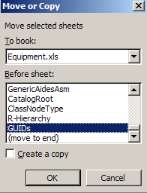

- Rename the new sheet to BoilerType1.

Note: Make sure you do not add any blank space or special characters for the name.

- Rename the name and description for both items as follows:

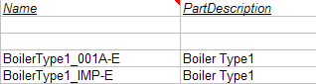

- Rename UserClassName and OccClassName as follows:

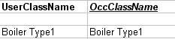

Note: The UserClassName is also known as a definition class name. You can use this field to provide a more meaningful name for the class or a name with blank spaces in it. This name appears in the Catalog task and Catalog browser dialog box. The OccClassName appears in the business object hierarchy on the Object Type tab on the Filter Properties dialog boxes.

- Save the changes and use the Bulkload utility to load the new class. Remember to add the letter A to all new records.

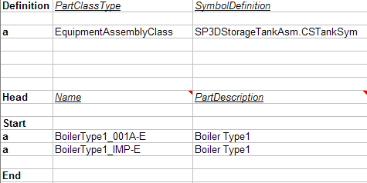

- Go to the Equipment Task and place the Boiler Type1.

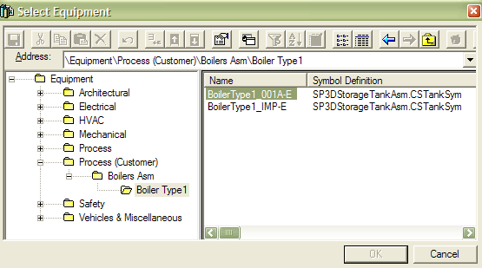

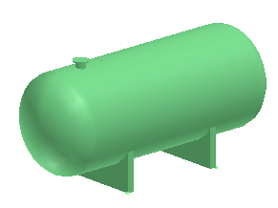

Lab 3: Working with the Custom Interface Sheet

Objective

After completing this lab, you will be able to:

- Add User Defined Code List attributes
- Add User Interfaces
Custom Interfaces
The Custom Interfaces sheet allows you to load a custom schema into the metadata of a catalog. This sheet defines the customized user interfaces and attributes (properties) for the smart/part classes in the workbook.

In this lab, you will add a new custom interface and three attributes for a smart class called BoilerType2. Also, you will create a new code list table namespace called Inspection Points in the catalog schema. Use the Custom Interfaces sheet to define the attributes names with associated data type, unit type and code list table namespace as shown below:
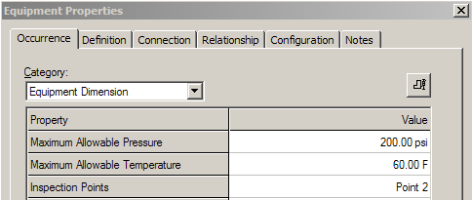

- Open the AllCodeList.xls Excel workbook. Copy this file to a working folder from:
C:\Program Files\SmartPlant\3D\CatalogData\BulkLoad\Datafiles. Don’t modify the delivered one.
- Add a User defined Code List as shown. You can create this worksheet from scratch, or copy and modify an existing one.

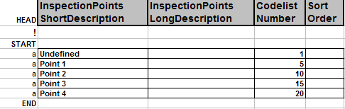

Note: The limit for a codelist name is 30 characters. You cannot use blanks or special characters for the codelist name.

- Open the Equipment.xls Workbook.

- Go to the R-Hierarchy sheet and add the following entry.

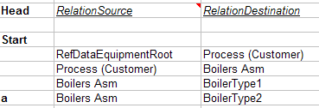

- Copy the BoilerType1 Smart Class by doing the following:
Select the BoilerType1 Sheet. Right Click to Open the Move or Copy dialog box. Enable the copy option. Copy the sheet next to GUIDs sheet.

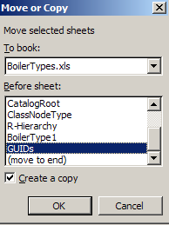

- Rename the sheet as BoilerType2

- Rename the name and description for both items as follows:

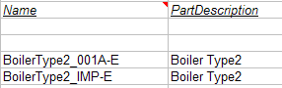

  - Rename UserClassName and OccClassName as follows:

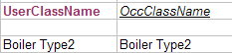

  - Create a new interface called IJUABoilerSpecs. Go to the CustomInterfaces sheet and add the following entries

Notes: An interface is a collection of attributes. A complete interface definition includes one or more attribute names with associated data type, unit type, and optional symbol parameter.

The appropriate UnitsType and the PrimaryUnits values are found using the UOM worksheet in AllCommon.xls workbook at C:\Program Files\SmartPlant\3D \CatalogData\BulkLoad\Datafiles.
The Category Names are listed in the Property Categories codelist. The codelist namespace for user-defined codelists is UDP.
  - Go to the BoilerType2 Smart Class Definition and key in the following data:

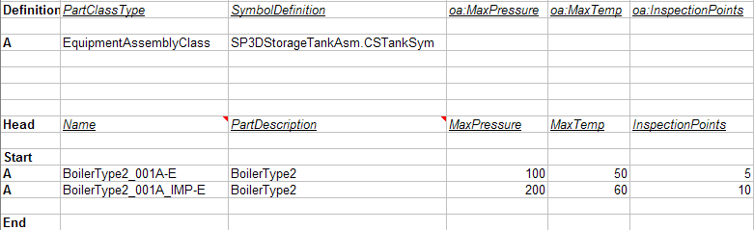

Note: Occurrence attributes are interpreted by the identifier ‘OA:’ and are defined along with the definition of the SmartClass in the SmartClass worksheets.
An attribute with the same name can exist on more than one interface. On our smart class sheet, you can scope the user attributes based on their interfaces and symbol parameters. The scoping syntax is Interface::UserAttribute<Symbol Parameter>.

  - Save the changes and use the Bulkload Utility to load the new class and the codelist. Remember to add the codelist file in the appropriate box as in the example below. 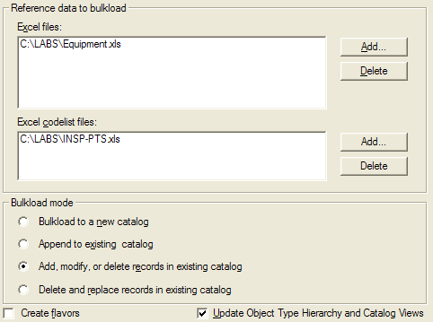
- Go to the Equipment Task and place the BoilerType2. Use the Equipment Properties page and review the new attributes under the Equipment Dimension category.

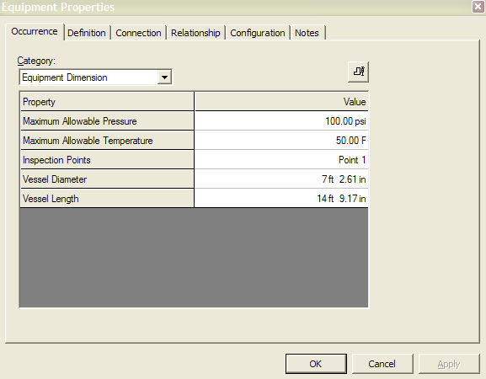

Lab 4: Part Class Modification
Objective
After completing this lab, you will be able to:

- Modify a Part Class Definition
- Hard-Code Parametric Values

Equipment Class Modification
A part class definition can be modified for different reasons. Some examples may include addition of new custom attributes or to redefine parametric values per approved vendor drawings.
This lab will step through the process of adding a new attribute into the equipment properties interface. Also parametric dimensions will be hardcoded into the interface and a new parametric legend illustration will be loaded.

- Open the Equipment.xls Excel workbook in your working folder
- Access the BoilerType1 worksheet
- At the end of “Definition” row enter: oa:InspectionPoints (see BoilerType2 for reference)
Note: This will insert InspectionPoints in the occurrence attributes (oa) form
- At the end of “Head” row enter: InspectionPoints (see BoilerType2 for reference)
Note: This defines a column under which default values may be entered
- Copy the complete row for equipment definition “BoilerType1_IMP-E” and insert it in the line below to create a new equipment item definition for this part class
- Change the Name attribute in the copied equipment line to “BoilerType1_Lab”
- Update the PartDescription value for this equipment to “New Boiler”
- For the same item, enter “800lbm” under DryWeight
- Enter “10ft” under VesselLength, and “4.25ft” under VesselDiameter
- Set all Support parameters to “1in” (can’t be 0)
- Set nozzles 1 and 2 NPD parameters to 4
- Set nozzles 3, 4, and 5 to blank by deleting their parameters cells contents
- Set InspectionPoints value to 25
- In column A row 8 of the worksheet enter an “m” to modify the part class to include the InspectionPoints parameter as shown in the illustration
- In column A in the row defining the new boiler enter an “a” to append this new item into the equipment catalog as shown in the illustration
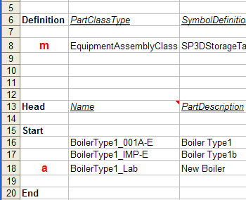
- Save the changes and use the Bulkload Utility in A/M/D mode to load the new boiler and modify the part class
- Enter SP3D Equipment task and place new boiler “BoilerType1_Lab”


Lab 5: Part Class Dimensional Legend Modification
Objective
After completing this lab, you will be able to:

- Modify a Part Class’ Dimensional Legend Definition

Dimensional Legend Modification
A part class definition includes the name of the graphic file that represents the dimensional legend for the equipment parametric. In the following steps a basic dimensions sheet is created to replace the delivered one.

- Open the Equipment.xls Excel workbook in your working folder and access the BoilerType1 worksheet
- Take note of the name of the graphics file containing the dimensional legend for BoilerType1 part class. It is found on column F under the “Symbolicon” header.
NOTE: For SymbolIcons\SP3DStorageTankAsm.gif the first name is the folder name in the Symbols share, the name after the slash is the graphic file name.
- Copy the symbol file from <symbols share>\SymbolIcons\ SP3DStorageTankAsm.gif to your working folder, i.e. C:\Labs
- Open the SP3DStorageTankAsm.gif file for reference
- Create a new dimensional legend, you can copy/paste from the original or create your own, for example:
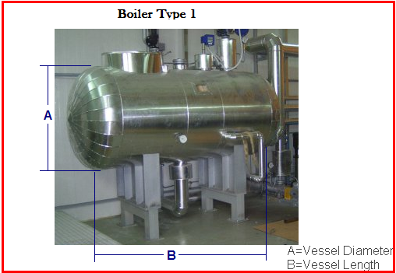
- Save the file with a new name: SP3DBoiler1.gif
- Copy SP3DBoiler1.gif to folder <symbols share>\SymbolIcons\ SP3DBoiler1.gif
- Modify BoilerType1 worksheet to insert the new gif legend file name for the boiler:
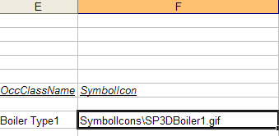
- In column A row 8 of the worksheet enter an “m” to modify the part class to revise the dimensional legend file name:
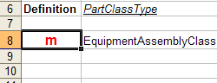
- Save the changes and use the Bulkload Utility in A/M/D mode to load the boiler modifications
- Enter SP3D Equipment task and select to place the new boiler “BoilerType1_Lab”
- Prior to placement, select the button to display the dimensional legend
The file SP3DBoiler1.gif will be displayed

